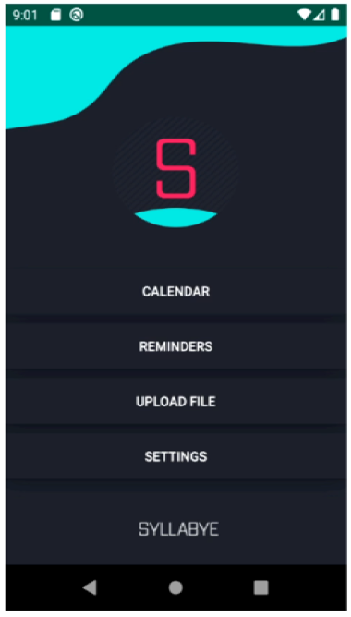

Android studio was used to create the UI. This UI has a breakdown of the calendar feature, reminders, file uploading, and settings. This front-end has been successfully paired with the other data structures and API to create the Syllabye app.

This whole cycle repeats itself with each addition of a new syllabus being added to the calendar.

The parser works by implementing the use of RegEx. The RegEx patterns parse through the output provided by Tesseract and create an output file with the respective dates converted into a format readable for the calendar data structure

The calendar data structure is a series of linked lists that holds 4 items under each list, within the list. These four items are, act (Homework, Exam, Final), Course (Ex. CSCI 3030), month, and day. The month and day are provided from Tesseract’s parsed data, whereas the course and act are provided by the user from the UI.

Tesseract OCR handles the uploaded file and converts the picture or document into text that is able to be parsed.